Assessment: Assignment 1

Student Name: Zahi Masarwa

Lab Professor Name: Alem Legesse

Lab Section Number: 303

Due Date: 04/16/21

# 1) Create Country table with the name Country_t

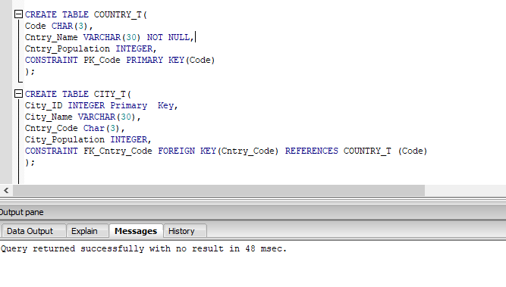

# 2) Create City table with the name City_t

# 

# 3) Modified Customer_T table by taking the same create table from inventory DDL and added new column named Cust_Country and added constraints.

# 

# 4) Modified Product_T table by taking the same create table from inventory DDL and added new column named Cntry_Origin to it and add constraint.

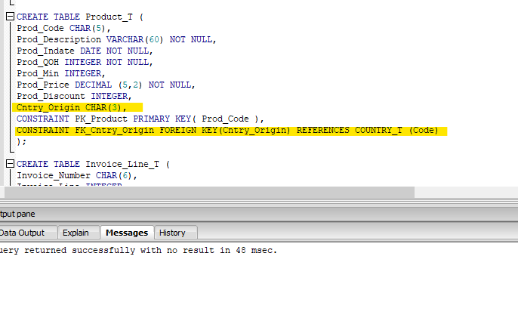

# 5) Populated the tables Country_T and City_t in multiple rows of data.

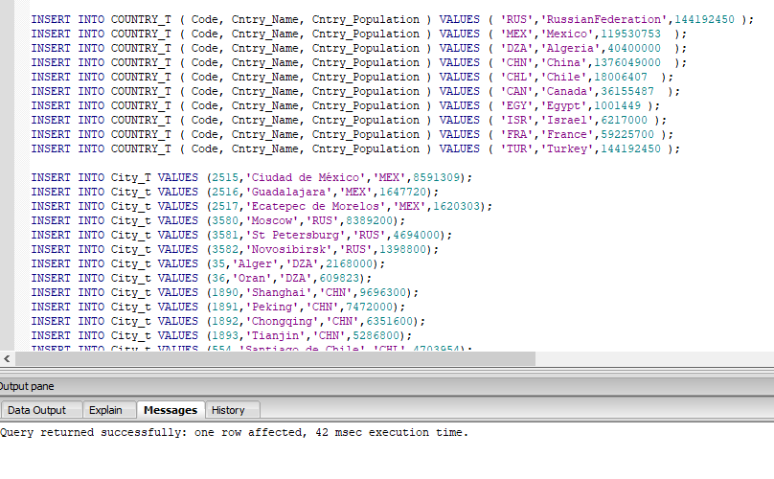

# 6) populated the rows in Customer_T and Product_T tables the same from inventory database and added data to the new column that created in both tables.

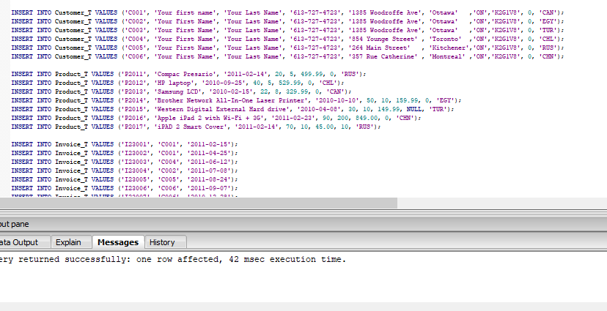

# 7) Added drop table in this order and it did drop the tables. If I changed the order, I received an Error.

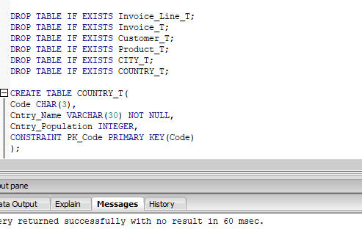

# 8) Created Views named CanadaCitys_V and Nodiscount_V.

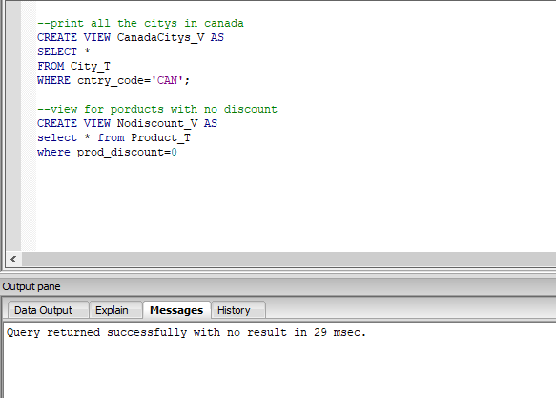

# 9) Delete Statement.

a) Tried to delete rows from Customer_t table, got an error. The error is a result of constraint relation to another table in the database needed to be removed or handled then we can use delete.

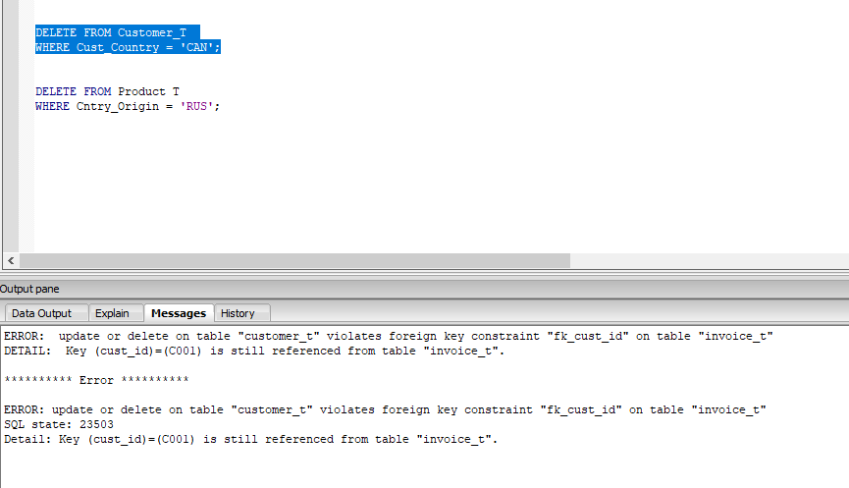

b) Tried to delete rows from Product T table but got an Error. The error is because the table Product doesn’t exist in the database. The correct name of the table is Product_t.

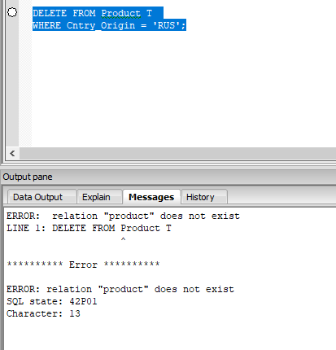

# 10)Joined two tables into one table with the condition needed

a) List of countries that don’t have any customers 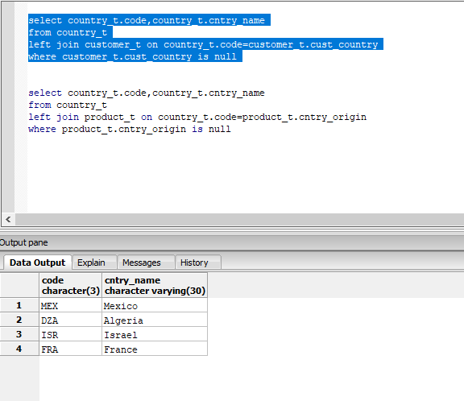

b) List of the countries that have not sold products

